**Lending Club Issued Loans Analysis Protocol**

*Author(s): Feldman Nadav   
 Burkis Konstantin*

# Introduction

In this project we analyzed Landing Club[1] Issued Loans data with the aim of estimating the credit risk of each loan, independent of LB's estimation.

Although there are several approaches to estimate credit risk, such as estimating the exposure at default (EAD) and the loss given default (LGD), in this work we studied only the probability of defaulted (PD) method, meaning estimating the probability to default of each given loan, by using classification algorithms to score each loan.

Credit risk problems have great importance for credit providers such as banks or credit cards companies and credit risk rating models are at the heart of their business model, evidence of this can also be seen in the constant preoccupation of the regulator with this subject.

Therefore, there is no wander that credit risk problems have been studied extensively, both in industry and academy and in particular, Lending Club data have been studied by many.

From the algorithmic point of view, there is a lot to studies from (Baesens et al., 2003)[2] who set up a benchmarking state of the art classification algorithms for credit scoring by applied various state of the art classification algorithms on to eight real-life credit scoring data sets. they found that both the LS-SVM and neural network classifiers yield a very good performance, but also simple classifiers such as logistic regression and linear discriminant analysis perform very well for credit scoring.

Another great resource, and much up to date, are (Lessmann & e.g., 2015)[3] whom updated the study of Baesens et al. and compared several novel classification algorithms to the state-of-the-art in credit scoring and found some advanced methods to perform extremely well on our credit scoring data sets, but never observe the most recent classifiers to excel.

From previous researches we can also study about important variables which are known to influence the probability to default, such as (Emekter, Tu, Jirasakuldech & Lu, 2015)[4] , which analyst Lending Club data[5] and found that credit grade (given by lending club), debt-to-income ratio, FICO score and revolving line utilization play an important role in loan defaults and that higher interest rates charged on the high-risk borrowers are not enough to compensate for higher probability of the loan default.

It should be noted that others also found loan purpose to be an important variable.

As mentioned, in this project we aimed to estimate the probability of defaulted independently to Lending Club estimation, hence we decided not to use any variable related to this estimation, including Lending Club credit grade.

In addition, while a proper definition of default is a case which a debtor has passed the payment deadline on a debt they were due to pay, in aim of making a better and more precise credit risk estimation and in order to decrease noises, we defined it as a case which the borrower failed to pay his debt. It should be noted that this definition is also consistent with definitions made in previous studies.

Finally, In order to create the best predicative model for probability of defaulted estimation, as defined above, we have set a number of baselines for comparison.

First, due to the unbalance nature of our problem and data (most of loans are paid), we would like to be more successful than if we had guessed that all the loans would be paid.

Second we would like to be more successful than Lending Club credit score[6], and third, we would like to be more successful than previous works done on the same Lending Club data set.

Although on one hand this subject has been studied extensively in the academia, and on the other hand much work has been done on this issue in less formal frameworks, we hoped that we would be able to create a good model against the baselines that we have set.

This was because we operate according to academic standards, but unlike academic studies, our sole goal was to produce as successful predictive model as possible, based on our data, and we were willing to try an extensive toolkit to achieve this goal.

# Methodology

## Data

## Data description

In our project we are using a dataset which was posted in Kaggle, [Lending Club Loan Data.](https://www.kaggle.com/wendykan/lending-club-loan-data)

It seems that the data can be downloaded directly from Lending Club Webpage <https://www.lendingclub.com/info/download-data.action>, but it may differ. Also as stated in Lending Club Webpage the data is not full, full data can be downloaded only after registration to the site therefore our dataset have a lot of missing values and some features are missing at all.

The downloaded dataset from Kaggle comes with a form of one .csv file or sqldb file. The file contain loan data for all loans issued through 2007-2015, including the current loan status (Current, Late, Fully Paid, etc.) and latest payment information. Additional features include credit scores, number of finance inquiries, address including zip codes, and state, and collections among others. The file contains 887,382 observations and 75 variables. A data dictionary is provided by Lending Club in a separate file in appendix (lcdatadictionary.xlsx).

## Data preparation

In order to make the data suitable to the course project requirements we divided the file into 6 tables which describe the loans details and the loaner's details. The final ER Diagram of the database that we created is shown below.

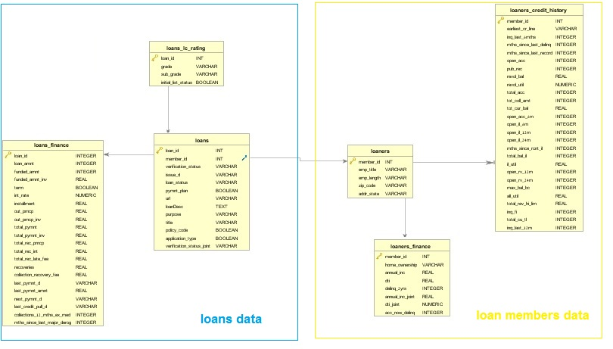

Figure 1 - ER Diagram of database

One of the possible external data that we thought and that may enrich our data considering that we have the state of each loan is the poverty rate of the state in that time.  
We downloaded poverty rates by states in the years 2007 – 2015 of loans from

<https://www.census.gov/cps/data/cpstablecreator.html>.

## Outcome variable definition

Our ultimate goal is the prediction of borrower failed to pay his debt, which we defined as Defaulted. The variable loan status seems to be an indicator of the current state a particular loan is in.

The different loan statuses in our data and their spread shown in Table 1 - Loan statuses statistics and Figure 2 - Loans statistics.

| **loan_status** | **count** | **rel_count** |
| --- | --- | --- |
| Charged Off | 45248 | 0.0510198214 |
| Current | 601340 | 0.6780467509 |
| Default | 1219 | 0.0013744953 |
| Does not meet the credit policy. Status:Charged Off | 761 | 0.0008580729 |
| Does not meet the credit policy. Status:Fully Paid | 1988 | 0.0022415887 |
| Fully Paid | 207723 | 0.2342200839 |
| In Grace Period | 6250 | 0.0070472481 |
| Issued | 8396 | 0.0094669913 |
| Late (16-30 days) | 2357 | 0.0026576582 |
| Late (31-120 days) | 11589 | 0.0130672894 |

Table - Loan statuses statistics

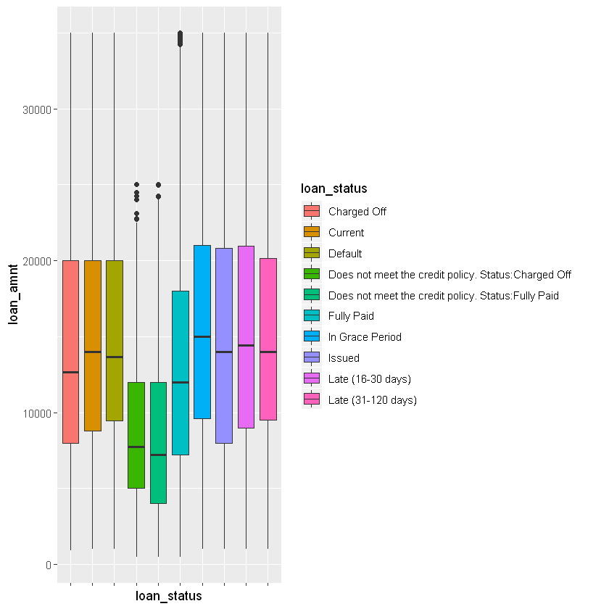

Figure - Loans statistics

It is not immediately obvious what the different values stand for, so we refer to Lending Club’s documentation about “[What do the different Note statuses mean?](https://help.lendingclub.com/hc/en-us/articles/215488038-What-do-the-different-Note-statuses-mean-)”

* **Fully Paid:** Loan has been fully repaid, either at the expiration of the 3- or 5-year year term or as a result of a prepayment.
* **Current:** Loan is up to date on all outstanding payments.
* **Does not meet the credit policy. Status:Fully Paid:** No explanation but see “fully paid”.
* **Issued:** New loan that has passed all Lending Club reviews, received full funding, and has been issued.
* **Charged Off:** Loan for which there is no longer a reasonable expectation of further payments. Generally, Charge Off occurs no later than 30 days after the Default status is reached. Upon Charge Off, the remaining principal balance of the Note is deducted from the account balance. Learn more about the [difference between “default” and “charge off”](https://help.lendingclub.com/hc/en-us/articles/216127747).
* **Does not meet the credit policy. Status:Charged Off:** No explanation but see “Charged Off”
* **Late (31-120 days):** Loan has not been current for 31 to 120 days.
* **In Grace Period:** Loan is past due but within the 15-day grace period.
* **Late (16-30 days):** Loan has not been current for 16 to 30 days.
* **Default:** Loan has not been current for 121 days or more.

Given above information, we will define a default (**Outcome**) as follows:

**Defaulted**loans are in status:

1. Charged Off
2. Does not meet the credit policy. Status:Charged Off

**Fully Paid** loans are in status:

1. Fully Paid
2. Does not meet the credit policy. Status:Fully Paid

For the other possible statuses we don't have a definite outcome of the loan therefore we will exclude them from our dataset.

We have these variables in our dataset which are indications of the outcome - determined by Lending Club after the company evaluations of the credit risk.

* grade
* sub_grade
* int_rate

These are confounder variables that may affect the outcome so we drop them.

We also transform the variable ***installment*** as it was calculated with the interest rate that LC is calculated for the loan. New variable ***loan_installment*** was calculated as the "clean" calculation of $\frac{loan_amount}{term}$.

After definition of our ***outcome*** value and definition of our question we can remove all columns that are not defined at the beginning of the loan evaluation process:

* last_pymnt_d
* next_pymnt_d
* collection_recovery_fee
* last_pymnt_amnt
* out_prncp
* out_prncp_inv
* recoveries
* total_pymnt
* total_pymnt_inv
* total_rec_int
* total_rec_late_fee
* total_rec_prncp

By their definitions provided in the data dictionary, they all relate to later or current stages of the loan therefore are not relevant to the initiate state of the loan.

In the context of fear of bias, in our database there are two main reasons for concern:

1. The fact that the database contains only information about people who received a loan from the LC. As a result, it is reasonable to assume that we will find in the data fewer people who are dangerous relative to their existence in the general distribution of the population, i.e. it may lead to a **selection bias**. For example, it is nice to see that the max dti (debt to income ratio) is 39.9, while in Lending Club web site it is noted that: "**Ideally, your debt-to-income ratio would be lower than 40%. That’s generally the threshold used across the industry. If your DTI is higher than 40%, your loan application will likely be denied."**

Therefore, we must remember that our model is only good for assessing people who have passed the baseline criteria of LC.

This means that in order to correctly use our model, the user must first run filtering according to LC base criteria.

1. There is a concern that the **distribution of data from past years is different from the distribution in later years, and in particular in the current time, in which we want the model to work.** That because LC experienced a significant increase in its activity during the measured time and there is a danger that the mix of borrowers operating through LC has changed over time.

To deal with Potential bias number 2, we consider excluding some past years.

We did tested the different distribution of the Defaulted variable, which is our outcome variable, in each different year.

Also we checked a bout lending club history business model both in LC website and Wikipedia.

We didn't found any clues that Lending Club changed its business model, but we did identified that issued year variable effect on defaults rates was significant, as the reader can see in section 5, data exploration.

However, deleting the first few years also did not succeed in concealing the effect.

## 4. Data enrichment

In order to enrich our dataset we found 2 pairs of variables that interaction between them may provide additional information.

* open_acc and total_acc describing the total and opened number of credits lines in the borrower's credit file we can divide them to show a ratio between them as an indicator of the borrower's activity.
* earliest_cr_line and last_credit_pull_d describing the date of the first credit line and the last pull date that was made by Lending Club so if we calculate the difference we can see the length or age of credit history.

For better visualizations and to properly merge the poverty rate data we transform the addr_state variable that contain the states in their abbreviated form into the full state name.

As stated before we also enriched the dataset with external poverty rate data. We created a variable that will show the poverty rate in the specific state in the time of the loan issue date.

5. Data exploratory analysis

The exploratory stage we begin with checking statistical analysis of the variables, with summary function and Table1 (Table 4 - Table one) we check the mean, median, Iqr, min, max SD values.

For each variable and we also checking the NA and unique ratios to fill the data retrieval protocol.

In Table 1(Table 4 - Table one) we can already see some variables that have p-value>0.05 for example pub_rec,pymnt_plan… and variables that have p-value <0.05 for example acc_now_delinq,loan_installment. 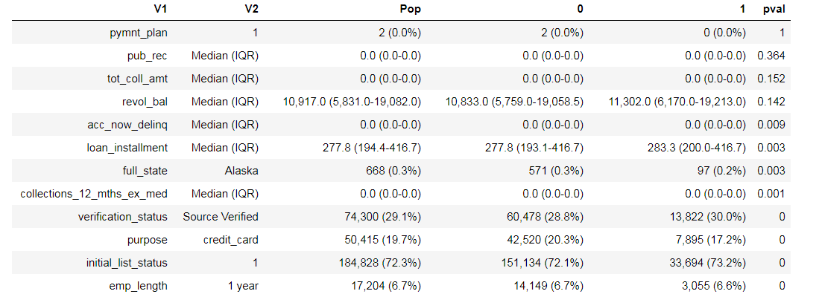

We can also see that we have a lot of variables with a very high missing rate like open_acc_6m and total_bal_il…

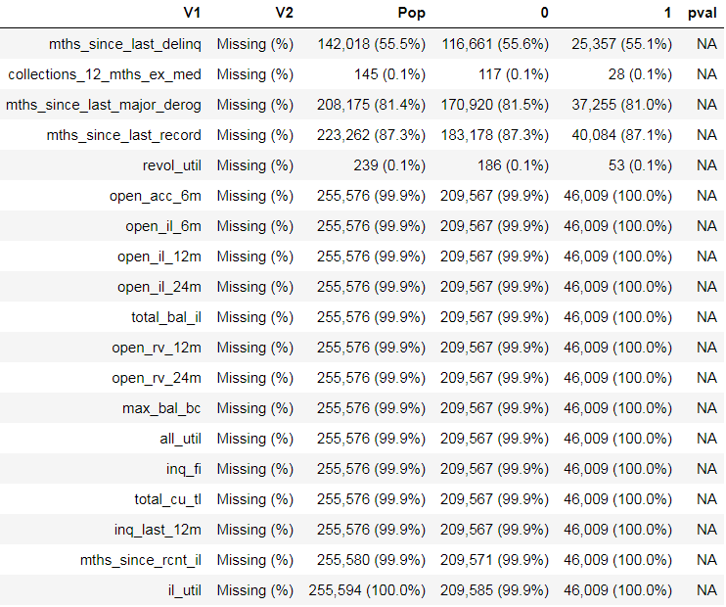

In another outlook of the table we can see which variables have median that is similar to their mean, which can be an indicator to a normal distribution. From the other hand, we can see which variables have median that differ from their median, and there for not normally distributed.

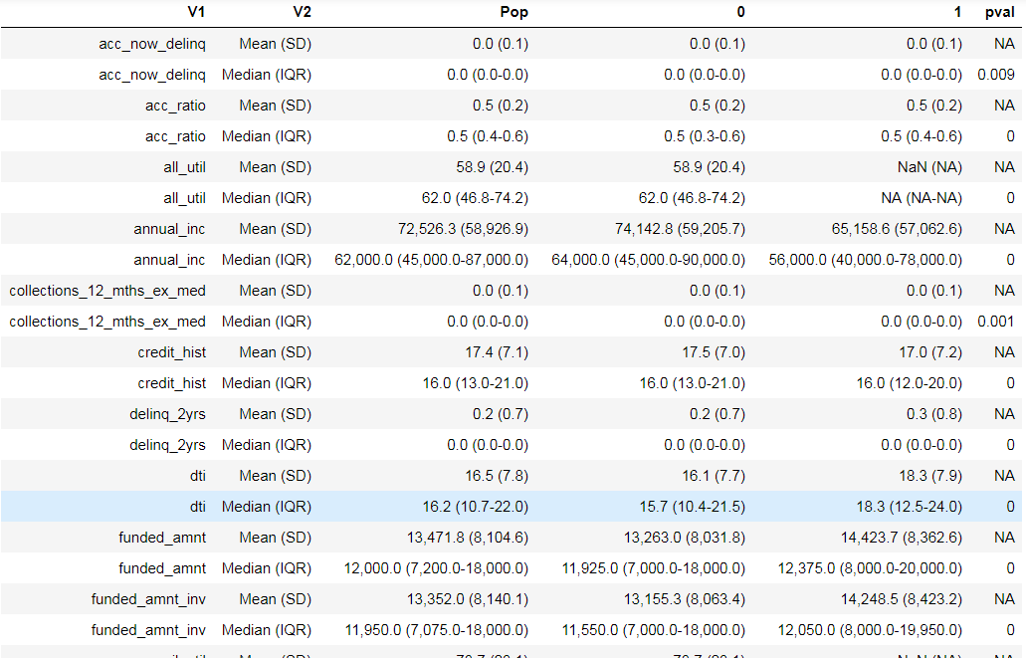

We continue the exploration with graphics visualizations of our variables. For each type of variable we will create specific plots:

● Categorical variables: barplot  
● Numeric Variables: histogram (distplot)   
● Numeric vs. Categorical: boxplot  
● Numeric vs. Numeric: scatter plot  
● Pairs

In the graph below, we can see the number of loans issued to the different purposes, divided to loans that had paid successfully and loan that defaulted. We can see that debt consolidation is the most common purpose and credit card is the second most common. From this graph we didn’t identified any purpose that has higher defaulted ratio then others, even though with the help of table one above, we could identified that Purpose is a good variable at separating between the paid loans to the defaulted.

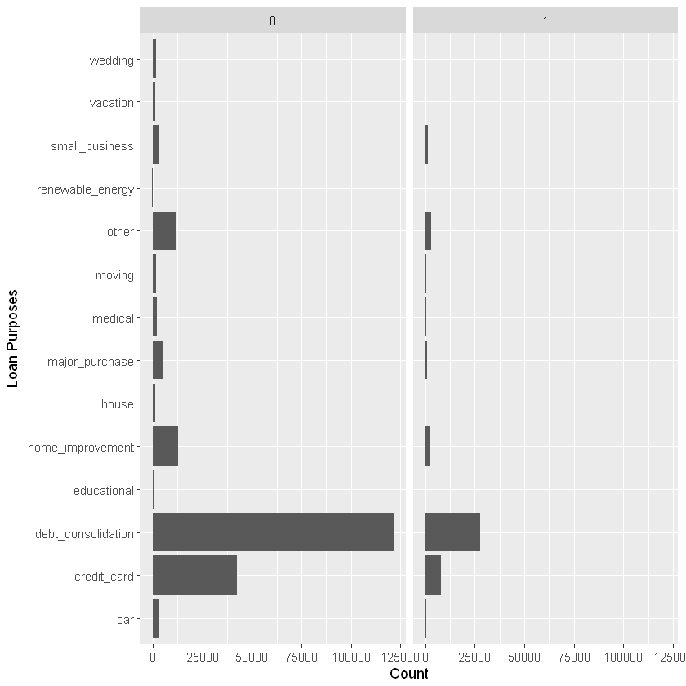

In the plot below we can see the histogram of some the numerical variables. It should be noted that some of the variables are count variables.

From the histograms we can get another clues about the data distribution.

For example, founded_amnt and funded_amnt_inv distributions seems very similar to each other and a bit close to normality distribution with a little bias towards the lowers values.



We also performed a normality distribution test to continuous variables using Kolmogorov-Smirnov normality test[7] and a normality distribution test to all of numeric variables using Anderson-Darling normality test[8] .

We did used it to check our variables distributions against theoretical normal distribution. We also did plot a Q-Q[9] plots of our variables distributions against theoretical normal distribution.

According to the KS test, not even one of the continuous variables is normally distributed[10].

According to the AD test, the only numerical variable which normally distributed is all_util[11].

Below you can see some of the Q-Q graphs (the first one is all_util ):

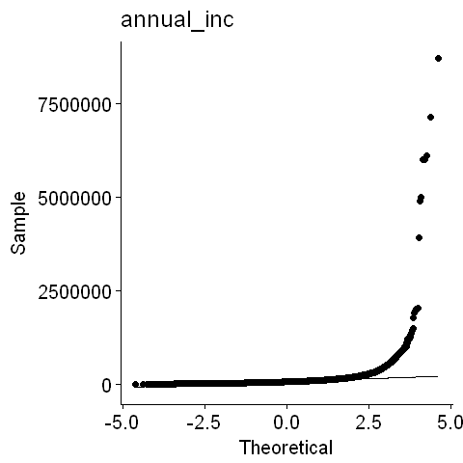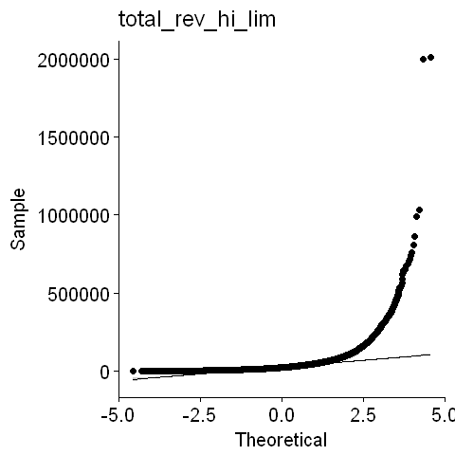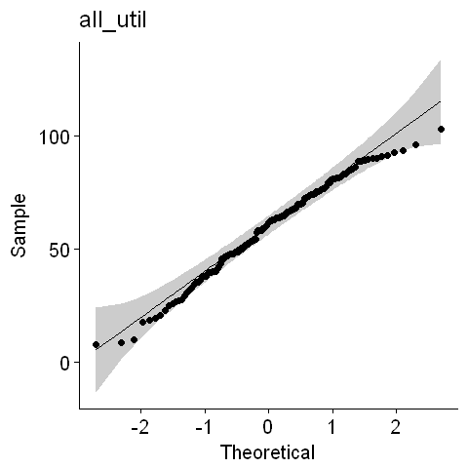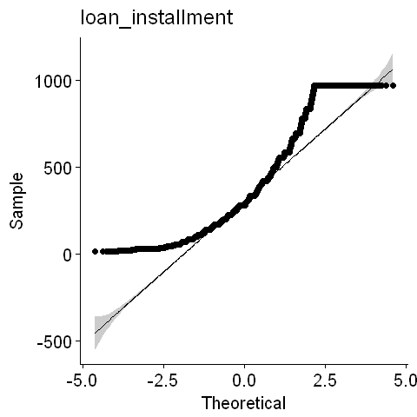

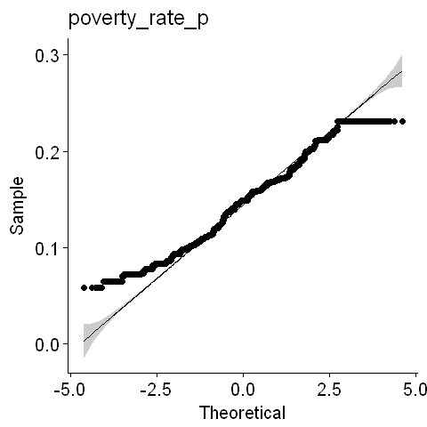

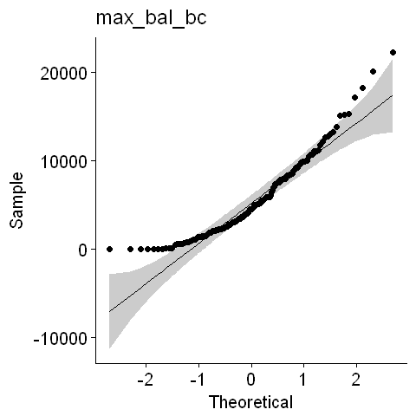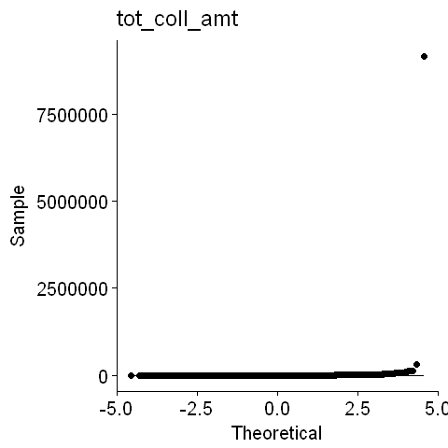



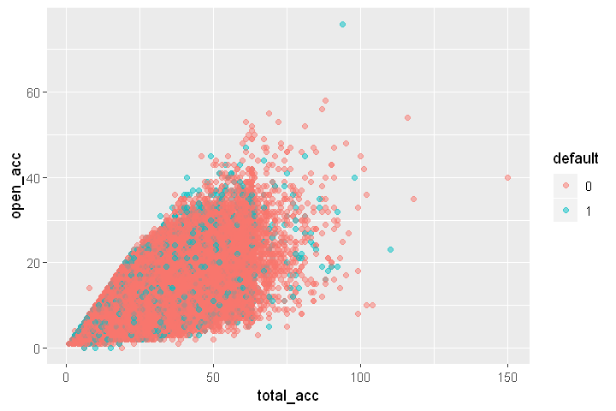From the graphs above we can study that despite of the KS and the AD tests, for practical work, there are some variables that may be sufficiently close to the normal distribution[12].

|  |  |
| --- | --- |
| Below there is a scatter plot of open_acc vs. total_acc. We can see that this pairs of variables are positively correlated. Throw that plot we also can identify some potentially outliers. These two variables are interesting to see in the same plot because we use the ratio between them to create a new variable. We can identify an area with an highly density of defaulted loans around the (50,40) coordinates. | Below there is a scatter plot of dti vs mnth since last major derog. In that plot its stands out that most of samples have less than 80 months since last major derog and above this value it should be suspected as an outlier. We also can see that most of defaulted loans are accrued when dti is higher than 25. |
|  |  |

In the plot below we can see that the loan amount is depends in the verified status, while the not verified loans are characterized by lower loan amount than the source verified which are characterized by lower loan amount than the verified loans.

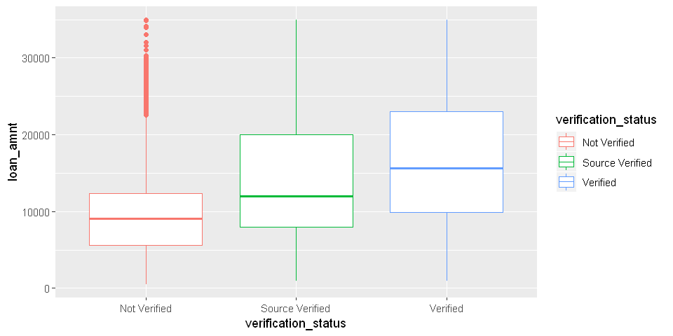

Even though the issue date variable is not going to be an exploratory variable in our final model[13], it is an extremely important check[14] in order to be careful from data biases. In the plot below, we can see the segmentation of fully paid and defaulted loans over every year in our data.

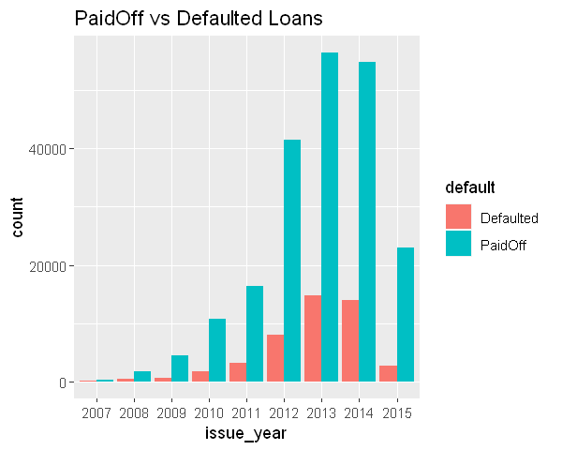

We can see, that the loans numbers in growth by the years and decrees at 2015. This dynamic is an outcome of the growth in Lending Club activity over the years and of the fact we have dataset till 2015 and we exclude loans with indefinite status, such as "current" status.

From this plot, we can't identify any meaningful different between the defaulted to paid ratios over the years. Even though with the help of ratio calculation and checking the Pearson's Chi-squared test we can see that year variable effect on the defaults is significant.

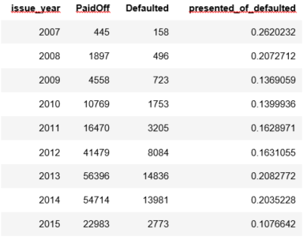

Pearson's Chi-squared test

data: loans$issue_year and loans$default

X-squared = 1933.7, df = 8, p-value < 2.2e-16

We see that in years 2007- 2008 the ratio is higher than in other years, so we tried to exclude those years from the dataset and rerun the Chi-squared test, but that still shows that the variable is significant.

Pearson's Chi-squared test

data: loans_ex_2008$issue_year and loans_ex_2008$default

X-squared = 1897.5, df = 6, p-value < 2.2e-16

From the pairs plot Figure 3 - Pairs plot we can study that:

1. There is a positive and high correlation between loan_amnt, funded_amnt_inv and loan installment. Furthermore, It is seems like funded_amnt_inv are equal to loan amount for most of the loans. Even though, there are some cases when they differ from each other.
2. We can identify tow lines in the scatter plot of loan installment and loans amount. Those lines are an outcome of the two possible different time terms of the loans (36 month of 60 month). That because the installment variable is an outcome of the loan amount variable divided by the loan time term.
3. It is very hard to see any correlation between dti and the others variables.
4. It is seems like revol_util is not strongly correlated with any other variable. Although, it may correlated with dti.
5. We can identify some samples that are suspects as an outliers in the loan_installment and the funded_inv scatter plots.
6. We can see that in 36 month term period the loan installment is higher than in the 60 month term period.
7. It is seems like annual_inc distribute exponential with a lot of samples in the low part of the distribution.
8. It seems like when term is 36 month the average loan amount is lower than if term is 60 month.

Figure - Pairs plot

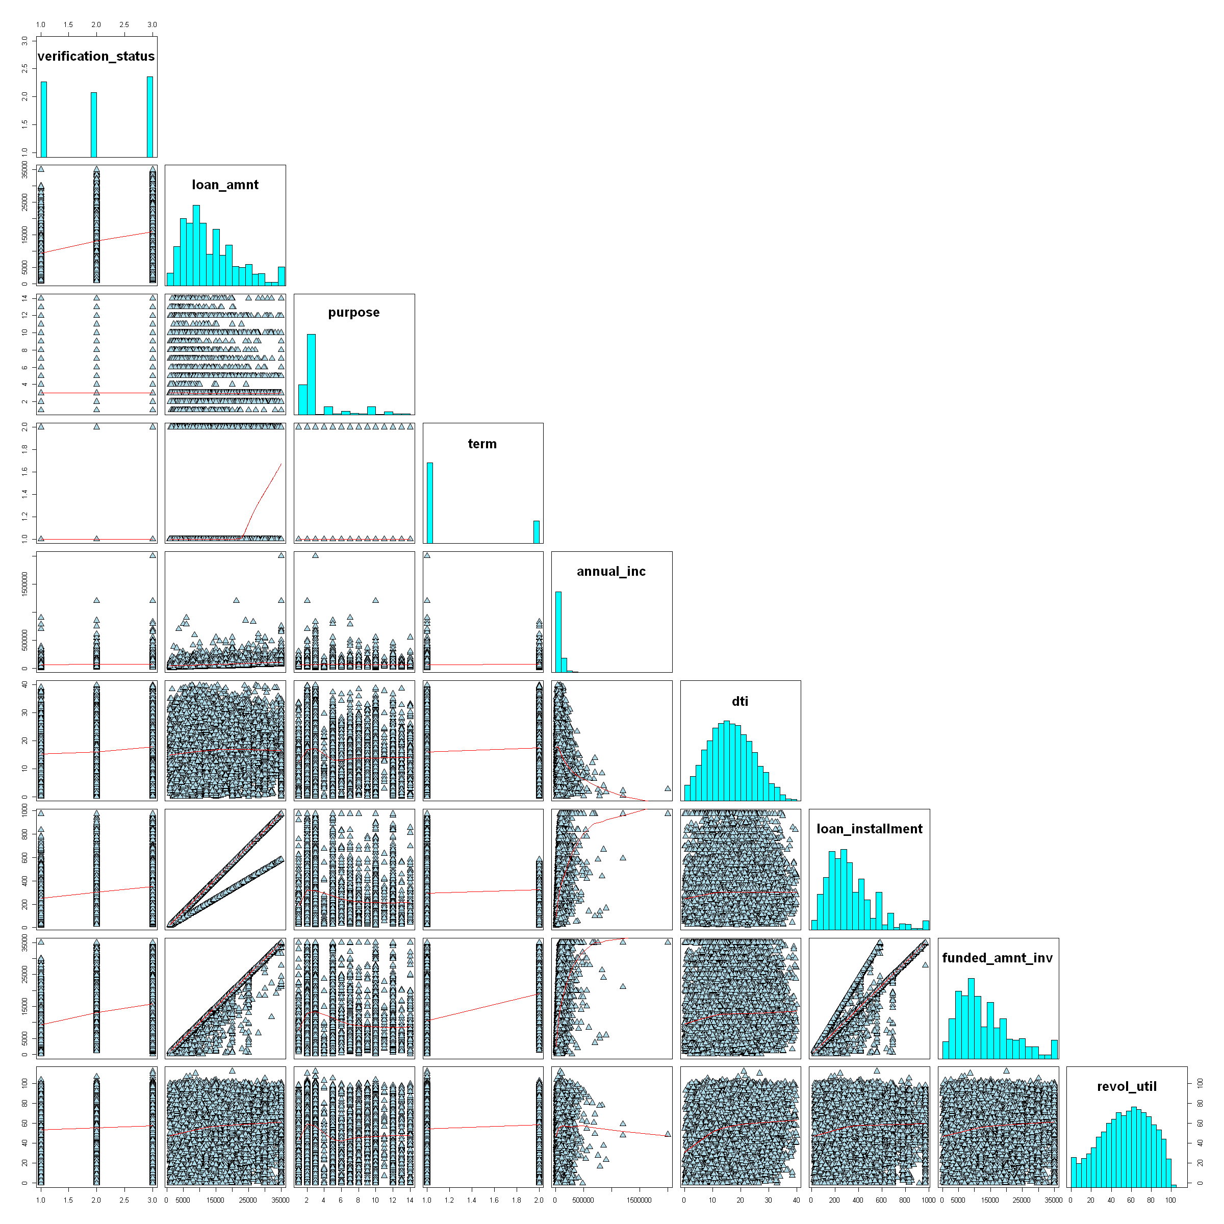

The outcome of the correlation table is consistent with our conclusions from the pairs plot.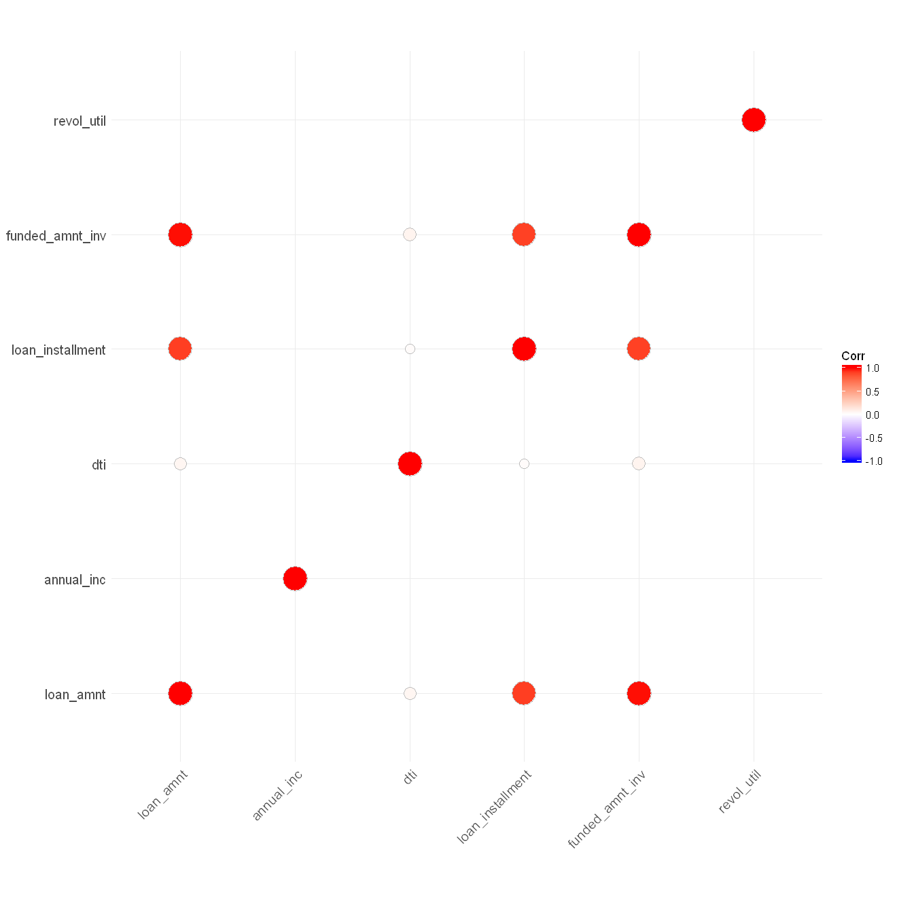

For additional visualizations and analysis there are EDA notebook (3-Exploratory Data Analysis.ipynb) and a report (report.html) in their designated folders.

After the visualizations we created more variables based on transformations and grouping to categories. Some of the originals variables show skewed distributions so we try to transform them with logarithmic and square root transformations.

For example the variable ***open_acc***:

|  |  |
| --- | --- |
| Open_acc | Open_acc with root transformation |
|  |  |

Some of our variables are count variables and have a small range of values and high percentage of the rows are around 0 and 1 so we group them into a categorical variable.

For example the variable ***pub_rec***:

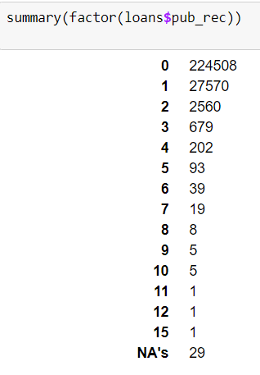

The variable has 14 different values but almost 90% of the rows are 0, so we creating a grouping variable which indicating if it's 0 or 1 and above.

## 6. Data cleansing

## 6.1 Dealing with outliers

We started with identification of univariate outliers in our data.

As we saw in the EDA article, according to the AD test, the only numerical variable which normally distributed is ***all_util***.

Therefore, in this work, we decided to use median and Interquartile range (IQR method), as showed by Tukey[15] (Tukey, 1977), by using boxplot for all variables.

Additionally we perform the Z score test only for ***all_util*** variable[16], by using function written by us. That due to the fact that use median and Interquartile range is more robust to un-normal distribution.

In the end of the EDA part we tried to perform a transformation on variables with far from normal distribution in order to make them more normally distributed alike.

In this stage of outliers detection we also demonstrated that the transformations indeed helped us detect outliers more precisely and therefore labeled less samples as an outliers.

During this check we did try to find a samples that are clearly a mistakes, in purpose of replacing them with NAs. We did that both by using data analysis methods and by investigating about lending club activity.

For an example to such case one can take a look on our findings about the ***tot_coll_amt*** variable. This variable giving an indication of what is the total collection amounts ever owed.

We found one sample with over than 9 million dollars that collected from him over all times, 30 times more than the second high amount collected!

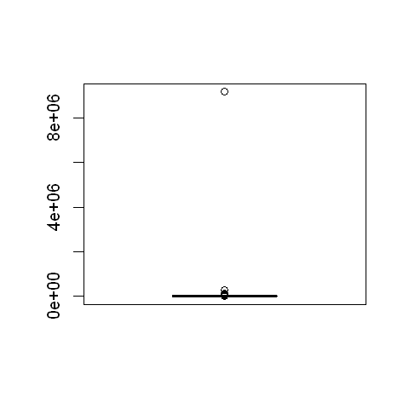

Who is this individual?

We found that this person have a low dti, nice but not very high annual income and a mortgage.   
For a person that don't own a home and his annual income less than 150,000 $, more than 9 million dollars paid in the past looks almost unreasonable!   
Therefore, it was reasonable for us to assume that this outlier is an outcome of an error and we replaced it with a NA.

We also labeled some interesting outliers that we found by creating a new binary variables.

For example we did created new variable that take the value 1 for all loans amount that is equal to 35,000$, which is the highest possible amount for loan amount that taken in LC platform, and 0 for all others amount.

After the univariate detection we proceed our outlier detection with multivariate outlier's detection. At first we used DBSCAN algorithm to cluster the data and after we did labeled the cluster which did not contain as many loan samples as an outliers. Additionally, we did perform a PCA in aiming to visualize the data.

In the plots below, you can see a sample of the data set labeled to clusters after the DBSCAN and labeled to outliers after our labeling base on the DBSCAN outcomes.

PCA visualization of the different clusters:

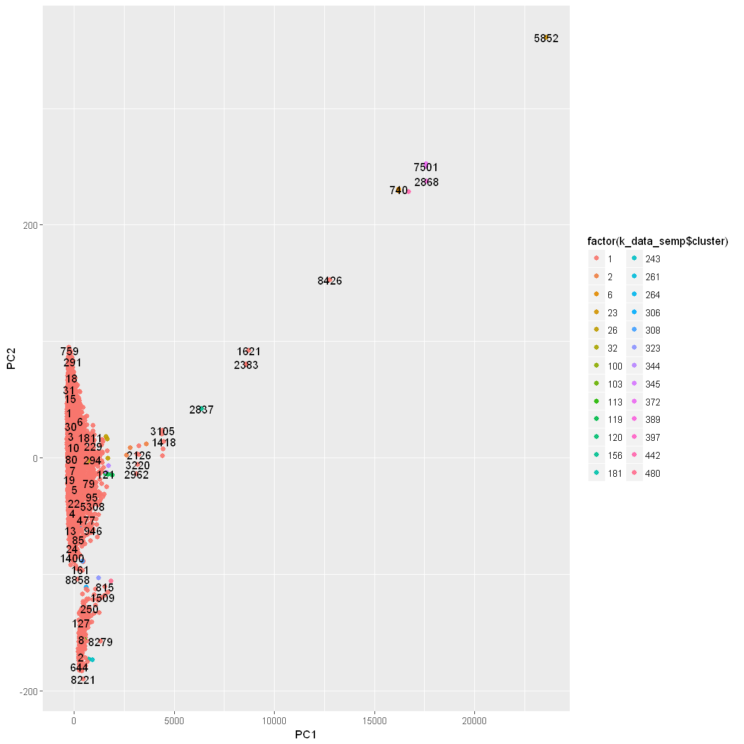

PCA visualization of the outliers:

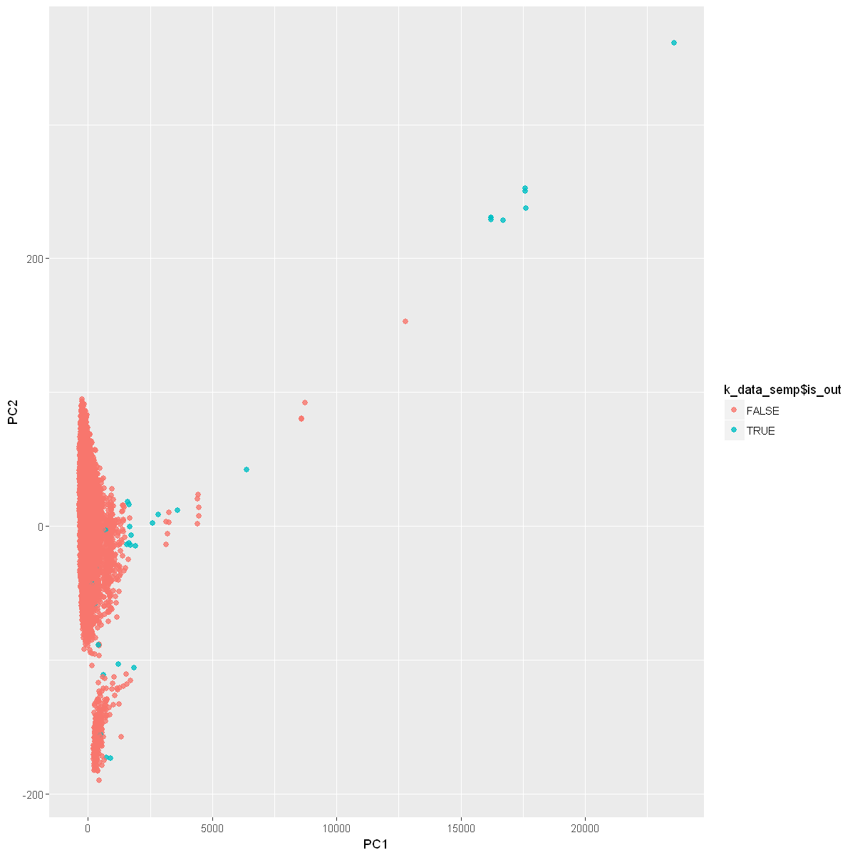

After labeling the outliers, in order to decide if we want to exclude the outliers or just to label them, we did checked if there is a relation between the "defaulted" variable, which is our outcome variable, to the ***is_out*** variable.

We did that by using Chi squared test to see if there is a correlation between the outliers and the outcome variable.

We found that is no significant correlation between the ***is_out*** variable and the default variable. But it is not so far from being significant, as you can see in below:

Pearson's Chi-squared test

data: k_data$is_out and k$default

X-squared = 2.7631, df = 1, p-value = 0.09646

We also did checked if the relationship between the loans that labeled as outliers to our outcome variable are differ from the relation between the other loans to our outcome variable and from the whole data set that include both the outliers and not outliers. We did that by using logistic regression on the three cases:

First, on the loans labeled as outliers versus the outcome variable,

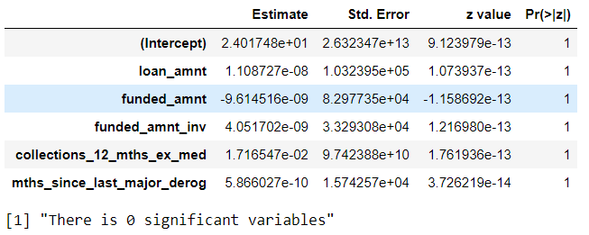

Second, on the data that didn’t labeled as outliers versus the outcome variable,

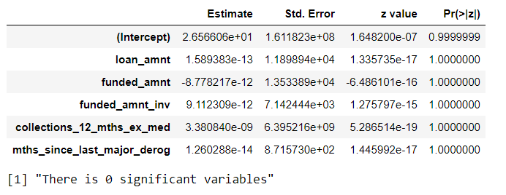

And third, on the whole data set.

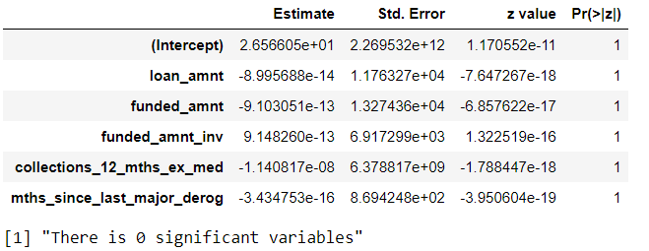

We didn’t find any significant coefficients in all cases that described above, hence we concluded that excluding the outliers don’t changed the relations between the outcome variable and the others variables and we drop those rows from our dataset.

## 6.2 Dealing with missing values

We will start our treatment by getting all the variables which have missing rows and find which variables are full.

Figure - Missing Variables

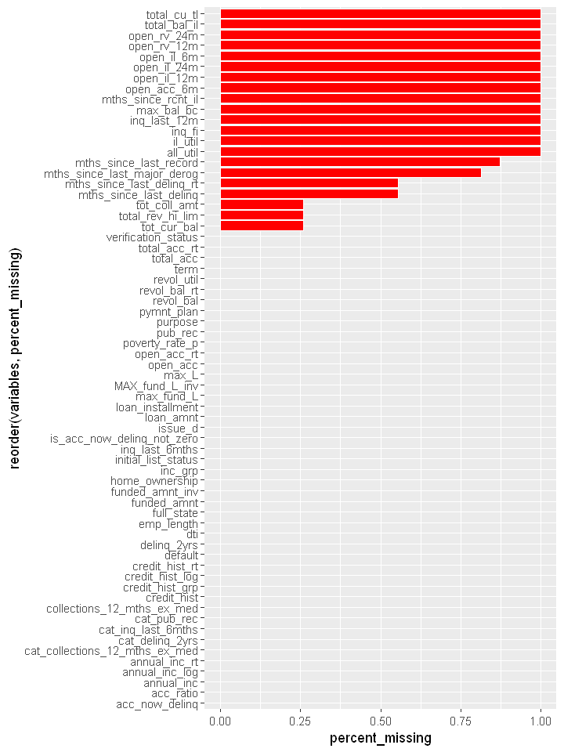

For each missing values variable we need to determine what type of missing mechanism it belongs. To do that we will generate dummy variable for each of the missing values variables that will indicate if it is a full or missing. Then we will run a logistic regression with all the full data (data with only the full variables) against this dummy variable as outcome (y).

In the result model we will check the coefficients and see how much of them are significant (p-value<0.05).

If there are 0 significant coefficients than it is MCAR mechanism, if there are more than 1 then we say it is MNAR.

In case of only one significant coefficient we will need to examine further the relationship of this variable with the missing variable and determine if it is a MCAR or MAR mechanism.

After the determination of the mechanism we need to decide on the treatment. For variables of MNAR mechanism we need to check the NA ratio of the data. If it is lower than 2-3% then we will delete the rows with NA values, otherwise we will remove this variable from our dataset.

For variables of MAR or MCAR mechanism we will try to apply an imputation technique.

We wrote and ran a function that implement the process described above and put it in table format with the results for each variable.

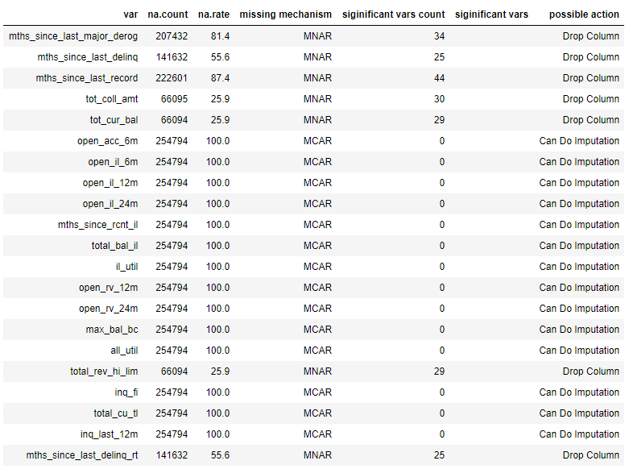

We see that the variables that defined as MCAR have a 100% NA rate so we can't do imputation on them, therefore we drop all the columns that have missing values.

## 7. Feature Selection

After the cleansing stages we have a dataset with all relevant features, original and engineered and doesn’t contain missing values. To prepare it further for modeling we need to encode the categorical variables. For categories with more than 2 values we will use one hot encoding which creates for each category variable dummy columns indicating which category it belongs to. After the encoding we ended with 138 columns.

For the process of feature selection we did univariate and multivariate analysis. We created  
a table with all the variables on the dataset and indicate the recommended variables for each  
technique analysis.

For the univariate analysis we used again the table one function which show us the variable p-values. For each variable with p-value lower than 0.05 we set 1 on the variable in the table.

For the multivariate analysis we used 4 different predictive models that recommend the features which have influence in the model.

1. LASSO (L1 penalization)
2. Random Forest
3. Gradient Boosting classification
4. SVM classification

We ended with the table of variables and indication for each technique analysis and summarization column that sums all the "voting" for each variable.

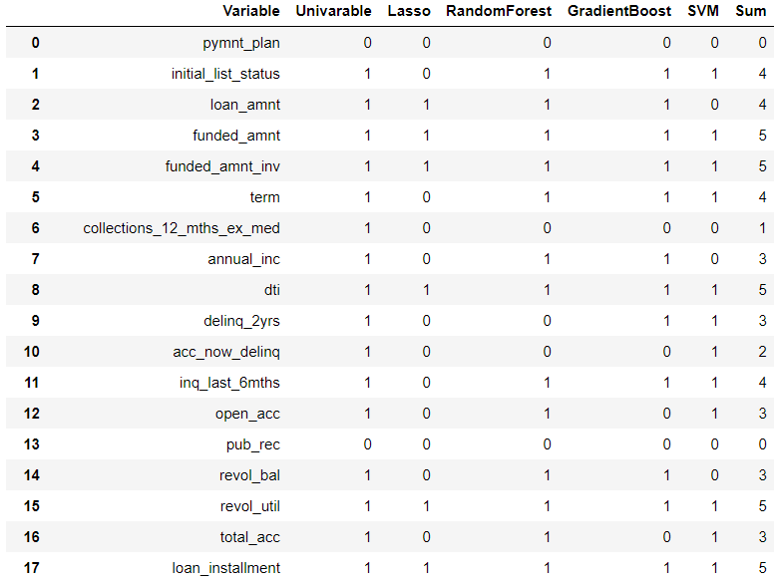

By this table with saw that we have a majority of variables that got 2 votes.

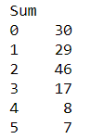

Therefore we selected a threshold of 2 votes and on this basis we select the variables that will be used as out final dataset for the model.

## Models

Here you have to describe how do you plan to develop your models:

* How do you plan to divide your data
  + Training, validation, test - proportions, techniques
* Do you need to balance your data? How?
* Do you need to stratify/subsample your data? How?
* What techniques will you apply to model your outcome?
  + Unsupervised
  + Regression
  + Classification
* Will you use cross-validation and/or bootstrap?
* Which measures you will use to train and evaluate your models? Why?
* Do you plan to use ensembling or will use your best model?

## Deployment of your model

* Who will make the QA of the project?
  + Which units will be assessed
  + Write a QA protocol for each step of the project
* Who is the final user of the predictions?
* How the prediction will be presented to the final user?
* How will the final user be trained to use and interpret the prediction?
* On which platform the predictions will be deployed?
* How frequently the model will be updated?
* What will happen in cases where the model return a null prediction (eg. incomplete data)?
* Which models were used and which were selected for the final prediction.
* Which measurements were used to evaluate the prediction.
* Which results we got from those models.

# Results

Here you will present the main results of all the process. We will describe:

* The final amount of data used (total, train, test, etc)
* The amount of outliers and the way of treating them,
* The amount of missing values and the methods used for imputing them,
* The distribution of the data (timeframes)
* The methods used to transform the data and to generate new features.

# Conclusion

Here you will write about how the project began, which were the most important challenges you had when developing the project, and how did you get the final prediction. You have to discuss also the limitations of the model, when it can be used and when not.

# Appendix

1. Data Dictionary By Lending Club

|  |  |
| --- | --- |
| **LoanStatNew** | **Description** |
| acc_now_delinq | The number of accounts on which the borrower is now delinquent. |
| addr_state | The state provided by the borrower in the loan application |
| all_util | Balance to credit limit on all trades |
| annual_inc | The self-reported annual income provided by the borrower during registration. |
| annual_inc_joint | The combined self-reported annual income provided by the co-borrowers during registration |
| application_type | Indicates whether the loan is an individual application or a joint application with two co-borrowers |
| collection_recovery_fee | post charge off collection fee |
| collections_12_mths_ex_med | Number of collections in 12 months excluding medical collections |
| delinq_2yrs | The number of 30+ days past-due incidences of delinquency in the borrower's credit file for the past 2 years |
| desc | Loan description provided by the borrower |
| dti | A ratio calculated using the borrower’s total monthly debt payments on the total debt obligations, excluding mortgage and the requested LC loan, divided by the borrower’s self-reported monthly income. |
| dti_joint | A ratio calculated using the co-borrowers' total monthly payments on the total debt obligations, excluding mortgages and the requested LC loan, divided by the co-borrowers' combined self-reported monthly income |
| earliest_cr_line | The month the borrower's earliest reported credit line was opened |
| emp_length | Employment length in years. Possible values are between 0 and 10 where 0 means less than one year and 10 means ten or more years. |
| emp_title | The job title supplied by the Borrower when applying for the loan.* |
| funded_amnt | The total amount committed to that loan at that point in time. |
| funded_amnt_inv | The total amount committed by investors for that loan at that point in time. |
| grade | LC assigned loan grade |
| home_ownership | The home ownership status provided by the borrower during registration. Our values are: RENT, OWN, MORTGAGE, OTHER. |
| id | A unique LC assigned ID for the loan listing. |
| il_util | Ratio of total current balance to high credit/credit limit on all install acct |
| initial_list_status | The initial listing status of the loan. Possible values are – W, F |
| inq_fi | Number of personal finance inquiries |
| inq_last_12m | Number of credit inquiries in past 12 months |
| inq_last_6mths | The number of inquiries in past 6 months (excluding auto and mortgage inquiries) |
| installment | The monthly payment owed by the borrower if the loan originates. |
| int_rate | Interest Rate on the loan |
| is_inc_v | Indicates if income was verified by LC, not verified, or if the income source was verified |
| issue_d | The month which the loan was funded |
| last_credit_pull_d | The most recent month LC pulled credit for this loan |
| last_pymnt_amnt | Last total payment amount received |
| last_pymnt_d | Last month payment was received |
| loan_amnt | The listed amount of the loan applied for by the borrower. If at some point in time, the credit department reduces the loan amount, then it will be reflected in this value. |
| loan_status | Current status of the loan |
| max_bal_bc | Maximum current balance owed on all revolving accounts |
| member_id | A unique LC assigned Id for the borrower member. |
| mths_since_last_delinq | The number of months since the borrower's last delinquency. |
| mths_since_last_major_derog | Months since most recent 90-day or worse rating |
| mths_since_last_record | The number of months since the last public record. |
| mths_since_rcnt_il | Months since most recent installment accounts opened |
| next_pymnt_d | Next scheduled payment date |
| open_acc | The number of open credit lines in the borrower's credit file. |
| open_acc_6m | Number of open trades in last 6 months |
| open_il_12m | Number of installment accounts opened in past 12 months |
| open_il_24m | Number of installment accounts opened in past 24 months |
| open_il_6m | Number of currently active installment trades |
| open_rv_12m | Number of revolving trades opened in past 12 months |
| open_rv_24m | Number of revolving trades opened in past 24 months |
| out_prncp | Remaining outstanding principal for total amount funded |
| out_prncp_inv | Remaining outstanding principal for portion of total amount funded by investors |
| policy_code | publicly available policy_code=1 new products not publicly available policy_code=2 |
| pub_rec | Number of derogatory public records |
| purpose | A category provided by the borrower for the loan request. |
| pymnt_plan | Indicates if a payment plan has been put in place for the loan |
| recoveries | post charge off gross recovery |
| revol_bal | Total credit revolving balance |
| revol_util | Revolving line utilization rate, or the amount of credit the borrower is using relative to all available revolving credit. |
| sub_grade | LC assigned loan subgrade |
| term | The number of payments on the loan. Values are in months and can be either 36 or 60. |
| title | The loan title provided by the borrower |
| tot_coll_amt | Total collection amounts ever owed |
| tot_cur_bal | Total current balance of all accounts |
| total_acc | The total number of credit lines currently in the borrower's credit file |
| total_bal_il | Total current balance of all installment accounts |
| total_cu_tl | Number of finance trades |
| total_pymnt | Payments received to date for total amount funded |
| total_pymnt_inv | Payments received to date for portion of total amount funded by investors |
| total_rec_int | Interest received to date |
| total_rec_late_fee | Late fees received to date |
| total_rec_prncp | Principal received to date |
| total_rev_hi_lim | Total revolving high credit/credit limit |
| url | URL for the LC page with listing data. |
| verified_status_joint | Indicates if the co-borrowers' joint income was verified by LC, not verified, or if the income source was verified |
| zip_code | The first 3 numbers of the zip code provided by the borrower in the loan application. |

Table - Table one

|  |  |  |  |  |  |
| --- | --- | --- | --- | --- | --- |
| "V1" | "V2" | "Pop" | "0" | "1" | "pval" |
| "Individuals" | "n" | "255720" | "209711" | "46009" | NA |
| "verification_status" | "Not Verified" | "87,897 (34.4%)" | "75,178 (35.8%)" | "12,719 (27.6%)" | NA |
| "verification_status" | "Source Verified" | "74,300 (29.1%)" | "60,478 (28.8%)" | "13,822 (30.0%)" | "0" |
| "verification_status" | "Verified" | "93,523 (36.6%)" | "74,055 (35.3%)" | "19,468 (42.3%)" | NA |
| "pymnt_plan" | "1" | "2 (0.0%)" | "2 (0.0%)" | "0 (0.0%)" | "1" |
| "purpose" | "car" | "3,710 (1.5%)" | "3,249 (1.5%)" | "461 (1.0%)" | NA |
| "purpose" | "credit_card" | "50,415 (19.7%)" | "42,520 (20.3%)" | "7,895 (17.2%)" | "0" |
| "purpose" | "debt_consolidation" | "149,464 (58.4%)" | "121,573 (58.0%)" | "27,891 (60.6%)" | NA |
| "purpose" | "educational" | "422 (0.2%)" | "334 (0.2%)" | "88 (0.2%)" | NA |
| "purpose" | "home_improvement" | "15,143 (5.9%)" | "12,803 (6.1%)" | "2,340 (5.1%)" | NA |
| "purpose" | "house" | "1,696 (0.7%)" | "1,399 (0.7%)" | "297 (0.6%)" | NA |
| "purpose" | "major_purchase" | "6,388 (2.5%)" | "5,491 (2.6%)" | "897 (1.9%)" | NA |
| "purpose" | "medical" | "2,912 (1.1%)" | "2,321 (1.1%)" | "591 (1.3%)" | NA |
| "purpose" | "moving" | "2,074 (0.8%)" | "1,634 (0.8%)" | "440 (1.0%)" | NA |
| "purpose" | "other" | "14,701 (5.7%)" | "11,644 (5.6%)" | "3,057 (6.6%)" | NA |
| "purpose" | "renewable_energy" | "270 (0.1%)" | "215 (0.1%)" | "55 (0.1%)" | NA |
| "purpose" | "small_business" | "4,907 (1.9%)" | "3,464 (1.7%)" | "1,443 (3.1%)" | NA |
| "purpose" | "vacation" | "1,607 (0.6%)" | "1,331 (0.6%)" | "276 (0.6%)" | NA |
| "purpose" | "wedding" | "2,011 (0.8%)" | "1,733 (0.8%)" | "278 (0.6%)" | NA |
| "initial_list_status" | "1" | "184,828 (72.3%)" | "151,134 (72.1%)" | "33,694 (73.2%)" | "0" |
| "emp_length" | "< 1 year" | "21,358 (8.4%)" | "17,395 (8.3%)" | "3,963 (8.6%)" | NA |
| "emp_length" | "1 year" | "17,204 (6.7%)" | "14,149 (6.7%)" | "3,055 (6.6%)" | "0" |
| "emp_length" | "10+ years" | "77,351 (30.2%)" | "64,062 (30.5%)" | "13,289 (28.9%)" | NA |
| "emp_length" | "2 years" | "23,910 (9.4%)" | "19,794 (9.4%)" | "4,116 (8.9%)" | NA |
| "emp_length" | "3 years" | "20,646 (8.1%)" | "17,040 (8.1%)" | "3,606 (7.8%)" | NA |
| "emp_length" | "4 years" | "16,402 (6.4%)" | "13,571 (6.5%)" | "2,831 (6.2%)" | NA |
| "emp_length" | "5 years" | "18,231 (7.1%)" | "14,978 (7.1%)" | "3,253 (7.1%)" | NA |
| "emp_length" | "6 years" | "14,897 (5.8%)" | "12,159 (5.8%)" | "2,738 (6.0%)" | NA |
| "emp_length" | "7 years" | "14,185 (5.5%)" | "11,551 (5.5%)" | "2,634 (5.7%)" | NA |
| "emp_length" | "8 years" | "11,956 (4.7%)" | "9,770 (4.7%)" | "2,186 (4.8%)" | NA |
| "emp_length" | "9 years" | "9,649 (3.8%)" | "7,851 (3.7%)" | "1,798 (3.9%)" | NA |
| "emp_length" | "n/a" | "9,931 (3.9%)" | "7,391 (3.5%)" | "2,540 (5.5%)" | NA |
| "loan_amnt" | "Mean (SD)" | "13,514.2 (8,127.1)" | "13,303.8 (8,053.3)" | "14,473.1 (8,388.9)" | NA |
| "loan_amnt" | "Median (IQR)" | "12,000.0 (7,200.0-18,200.0)" | "12,000.0 (7,075.0-18,000.0)" | "12,500.0 (8,000.0-20,000.0)" | "0" |
| "funded_amnt" | "Mean (SD)" | "13,471.8 (8,104.6)" | "13,263.0 (8,031.8)" | "14,423.7 (8,362.6)" | NA |
| "funded_amnt" | "Median (IQR)" | "12,000.0 (7,200.0-18,000.0)" | "11,925.0 (7,000.0-18,000.0)" | "12,375.0 (8,000.0-20,000.0)" | "0" |
| "funded_amnt_inv" | "Mean (SD)" | "13,352.0 (8,140.1)" | "13,155.3 (8,063.4)" | "14,248.5 (8,423.2)" | NA |
| "funded_amnt_inv" | "Median (IQR)" | "11,950.0 (7,075.0-18,000.0)" | "11,550.0 (7,000.0-18,000.0)" | "12,050.0 (8,000.0-19,950.0)" | "0" |
| "term" | "1" | "56,624 (22.1%)" | "40,347 (19.2%)" | "16,277 (35.4%)" | "0" |
| "collections_12_mths_ex_med" | "Mean (SD)" | "0.0 (0.1)" | "0.0 (0.1)" | "0.0 (0.1)" | NA |
| "collections_12_mths_ex_med" | "Median (IQR)" | "0.0 (0.0-0.0)" | "0.0 (0.0-0.0)" | "0.0 (0.0-0.0)" | "0.001" |
| "collections_12_mths_ex_med" | "Missing (%)" | "145 (0.1%)" | "117 (0.1%)" | "28 (0.1%)" | NA |
| "mths_since_last_major_derog" | "Mean (SD)" | "43.4 (21.6)" | "43.6 (21.6)" | "42.6 (21.8)" | NA |
| "mths_since_last_major_derog" | "Median (IQR)" | "43.0 (26.0-60.0)" | "43.0 (27.0-60.0)" | "42.0 (25.0-60.0)" | "0" |
| "mths_since_last_major_derog" | "Missing (%)" | "208,175 (81.4%)" | "170,920 (81.5%)" | "37,255 (81.0%)" | NA |
| "home_ownership" | "ANY" | "1 (0.0%)" | "1 (0.0%)" | "0 (0.0%)" | NA |
| "home_ownership" | "MORTGAGE" | "126,100 (49.3%)" | "105,874 (50.5%)" | "20,226 (44.0%)" | "0" |
| "home_ownership" | "NONE" | "48 (0.0%)" | "40 (0.0%)" | "8 (0.0%)" | NA |
| "home_ownership" | "OTHER" | "179 (0.1%)" | "141 (0.1%)" | "38 (0.1%)" | NA |
| "home_ownership" | "OWN" | "22,173 (8.7%)" | "18,099 (8.6%)" | "4,074 (8.9%)" | NA |
| "home_ownership" | "RENT" | "107,219 (41.9%)" | "85,556 (40.8%)" | "21,663 (47.1%)" | NA |
| "annual_inc" | "Mean (SD)" | "72,526.3 (58,926.9)" | "74,142.8 (59,205.7)" | "65,158.6 (57,062.6)" | NA |
| "annual_inc" | "Median (IQR)" | "62,000.0 (45,000.0-87,000.0)" | "64,000.0 (45,000.0-90,000.0)" | "56,000.0 (40,000.0-78,000.0)" | "0" |
| "annual_inc" | "Missing (%)" | "4 (0.0%)" | "4 (0.0%)" | NA | NA |
| "dti" | "Mean (SD)" | "16.5 (7.8)" | "16.1 (7.7)" | "18.3 (7.9)" | NA |
| "dti" | "Median (IQR)" | "16.2 (10.7-22.0)" | "15.7 (10.4-21.5)" | "18.3 (12.5-24.0)" | "0" |
| "delinq_2yrs" | "Mean (SD)" | "0.2 (0.7)" | "0.2 (0.7)" | "0.3 (0.8)" | NA |
| "delinq_2yrs" | "Median (IQR)" | "0.0 (0.0-0.0)" | "0.0 (0.0-0.0)" | "0.0 (0.0-0.0)" | "0" |
| "delinq_2yrs" | "Missing (%)" | "29 (0.0%)" | "26 (0.0%)" | "3 (0.0%)" | NA |
| "acc_now_delinq" | "Mean (SD)" | "0.0 (0.1)" | "0.0 (0.1)" | "0.0 (0.1)" | NA |
| "acc_now_delinq" | "Median (IQR)" | "0.0 (0.0-0.0)" | "0.0 (0.0-0.0)" | "0.0 (0.0-0.0)" | "0.009" |
| "acc_now_delinq" | "Missing (%)" | "29 (0.0%)" | "26 (0.0%)" | "3 (0.0%)" | NA |
| "inq_last_6mths" | "Mean (SD)" | "0.9 (1.2)" | "0.9 (1.1)" | "1.0 (1.3)" | NA |
| "inq_last_6mths" | "Median (IQR)" | "1.0 (0.0-1.0)" | "1.0 (0.0-1.0)" | "1.0 (0.0-2.0)" | "0" |
| "inq_last_6mths" | "Missing (%)" | "29 (0.0%)" | "26 (0.0%)" | "3 (0.0%)" | NA |
| "mths_since_last_delinq" | "Mean (SD)" | "35.1 (21.9)" | "35.3 (21.8)" | "34.1 (22.1)" | NA |
| "mths_since_last_delinq" | "Median (IQR)" | "32.0 (17.0-51.0)" | "33.0 (17.0-51.0)" | "31.0 (15.0-50.0)" | "0" |
| "mths_since_last_delinq" | "Missing (%)" | "142,018 (55.5%)" | "116,661 (55.6%)" | "25,357 (55.1%)" | NA |
| "mths_since_last_record" | "Mean (SD)" | "74.4 (31.1)" | "74.0 (30.7)" | "76.0 (32.5)" | NA |
| "mths_since_last_record" | "Median (IQR)" | "78.0 (54.0-101.0)" | "76.0 (53.0-101.0)" | "84.0 (55.0-103.0)" | "0" |
| "mths_since_last_record" | "Missing (%)" | "223,262 (87.3%)" | "183,178 (87.3%)" | "40,084 (87.1%)" | NA |
| "open_acc" | "Mean (SD)" | "10.9 (4.9)" | "10.9 (4.9)" | "11.0 (4.9)" | NA |
| "open_acc" | "Median (IQR)" | "10.0 (7.0-14.0)" | "10.0 (7.0-13.0)" | "10.0 (8.0-14.0)" | "0" |
| "open_acc" | "Missing (%)" | "29 (0.0%)" | "26 (0.0%)" | "3 (0.0%)" | NA |
| "pub_rec" | "Mean (SD)" | "0.1 (0.4)" | "0.1 (0.4)" | "0.1 (0.4)" | NA |
| "pub_rec" | "Median (IQR)" | "0.0 (0.0-0.0)" | "0.0 (0.0-0.0)" | "0.0 (0.0-0.0)" | "0.364" |
| "pub_rec" | "Missing (%)" | "29 (0.0%)" | "26 (0.0%)" | "3 (0.0%)" | NA |
| "revol_bal" | "Mean (SD)" | "15,299.6 (19,709.8)" | "15,326.0 (19,776.9)" | "15,179.0 (19,400.6)" | NA |
| "revol_bal" | "Median (IQR)" | "10,917.0 (5,831.0-19,082.0)" | "10,833.0 (5,759.0-19,058.5)" | "11,302.0 (6,170.0-19,213.0)" | "0.142" |
| "revol_util" | "Mean (SD)" | "54.3 (24.8)" | "53.2 (25.0)" | "59.4 (23.6)" | NA |
| "revol_util" | "Median (IQR)" | "55.8 (36.2-73.9)" | "54.5 (34.8-72.8)" | "61.6 (43.1-78.0)" | "0" |
| "revol_util" | "Missing (%)" | "239 (0.1%)" | "186 (0.1%)" | "53 (0.1%)" | NA |
| "total_acc" | "Mean (SD)" | "25.0 (11.8)" | "25.2 (11.8)" | "24.2 (11.6)" | NA |
| "total_acc" | "Median (IQR)" | "23.0 (16.0-32.0)" | "24.0 (17.0-32.0)" | "23.0 (16.0-31.0)" | "0" |
| "total_acc" | "Missing (%)" | "29 (0.0%)" | "26 (0.0%)" | "3 (0.0%)" | NA |
| "tot_coll_amt" | "Mean (SD)" | "203.8 (21,102.1)" | "219.8 (23,382.5)" | "133.9 (1,316.1)" | NA |
| "tot_coll_amt" | "Median (IQR)" | "0.0 (0.0-0.0)" | "0.0 (0.0-0.0)" | "0.0 (0.0-0.0)" | "0.152" |
| "tot_coll_amt" | "Missing (%)" | "66,457 (26.0%)" | "55,677 (26.5%)" | "10,780 (23.4%)" | NA |
| "tot_cur_bal" | "Mean (SD)" | "138,331.2 (152,436.7)" | "143,791.9 (157,054.2)" | "114,454.8 (127,626.4)" | NA |
| "tot_cur_bal" | "Median (IQR)" | "81,002.0 (28,372.5-208,229.0)" | "87,779.0 (29,146.2-216,689.8)" | "59,738.0 (25,670.0-172,573.0)" | "0" |
| "tot_cur_bal" | "Missing (%)" | "66,457 (26.0%)" | "55,677 (26.5%)" | "10,780 (23.4%)" | NA |
| "open_acc_6m" | "Mean (SD)" | "1.4 (1.3)" | "1.4 (1.3)" | "NaN (NA)" | NA |
| "open_acc_6m" | "Median (IQR)" | "1.0 (0.0-2.0)" | "1.0 (0.0-2.0)" | "NA (NA-NA)" | "0" |
| "open_acc_6m" | "Missing (%)" | "255,576 (99.9%)" | "209,567 (99.9%)" | "46,009 (100.0%)" | NA |
| "open_il_6m" | "Mean (SD)" | "3.1 (3.2)" | "3.1 (3.2)" | "NaN (NA)" | NA |
| "open_il_6m" | "Median (IQR)" | "2.0 (1.0-4.0)" | "2.0 (1.0-4.0)" | "NA (NA-NA)" | "0" |
| "open_il_6m" | "Missing (%)" | "255,576 (99.9%)" | "209,567 (99.9%)" | "46,009 (100.0%)" | NA |
| "open_il_12m" | "Mean (SD)" | "0.9 (1.2)" | "0.9 (1.2)" | "NaN (NA)" | NA |
| "open_il_12m" | "Median (IQR)" | "0.0 (0.0-1.0)" | "0.0 (0.0-1.0)" | "NA (NA-NA)" | "0" |
| "open_il_12m" | "Missing (%)" | "255,576 (99.9%)" | "209,567 (99.9%)" | "46,009 (100.0%)" | NA |
| "open_il_24m" | "Mean (SD)" | "1.9 (2.1)" | "1.9 (2.1)" | "NaN (NA)" | NA |
| "open_il_24m" | "Median (IQR)" | "1.0 (1.0-3.0)" | "1.0 (1.0-3.0)" | "NA (NA-NA)" | "0" |
| "open_il_24m" | "Missing (%)" | "255,576 (99.9%)" | "209,567 (99.9%)" | "46,009 (100.0%)" | NA |
| "mths_since_rcnt_il" | "Mean (SD)" | "20.7 (27.7)" | "20.7 (27.7)" | "NaN (NA)" | NA |
| "mths_since_rcnt_il" | "Median (IQR)" | "12.5 (4.0-21.0)" | "12.5 (4.0-21.0)" | "NA (NA-NA)" | "0" |
| "mths_since_rcnt_il" | "Missing (%)" | "255,580 (99.9%)" | "209,571 (99.9%)" | "46,009 (100.0%)" | NA |
| "total_bal_il" | "Mean (SD)" | "36,462.3 (38,137.6)" | "36,462.3 (38,137.6)" | "NaN (NA)" | NA |
| "total_bal_il" | "Median (IQR)" | "23,605.0 (10,763.8-50,835.8)" | "23,605.0 (10,763.8-50,835.8)" | "NA (NA-NA)" | "0" |
| "total_bal_il" | "Missing (%)" | "255,576 (99.9%)" | "209,567 (99.9%)" | "46,009 (100.0%)" | NA |
| "il_util" | "Mean (SD)" | "73.7 (23.1)" | "73.7 (23.1)" | "NaN (NA)" | NA |
| "il_util" | "Median (IQR)" | "77.0 (63.3-88.2)" | "77.0 (63.3-88.2)" | "NA (NA-NA)" | "0" |
| "il_util" | "Missing (%)" | "255,594 (100.0%)" | "209,585 (99.9%)" | "46,009 (100.0%)" | NA |
| "open_rv_12m" | "Mean (SD)" | "1.7 (1.6)" | "1.7 (1.6)" | "NaN (NA)" | NA |
| "open_rv_12m" | "Median (IQR)" | "1.0 (0.0-2.0)" | "1.0 (0.0-2.0)" | "NA (NA-NA)" | "0" |
| "open_rv_12m" | "Missing (%)" | "255,576 (99.9%)" | "209,567 (99.9%)" | "46,009 (100.0%)" | NA |
| "open_rv_24m" | "Mean (SD)" | "3.6 (2.9)" | "3.6 (2.9)" | "NaN (NA)" | NA |
| "open_rv_24m" | "Median (IQR)" | "3.0 (2.0-5.0)" | "3.0 (2.0-5.0)" | "NA (NA-NA)" | "0" |
| "open_rv_24m" | "Missing (%)" | "255,576 (99.9%)" | "209,567 (99.9%)" | "46,009 (100.0%)" | NA |
| "max_bal_bc" | "Mean (SD)" | "5,517.3 (4,507.6)" | "5,517.3 (4,507.6)" | "NaN (NA)" | NA |
| "max_bal_bc" | "Median (IQR)" | "4,511.5 (2,091.2-8,212.8)" | "4,511.5 (2,091.2-8,212.8)" | "NA (NA-NA)" | "0" |
| "max_bal_bc" | "Missing (%)" | "255,576 (99.9%)" | "209,567 (99.9%)" | "46,009 (100.0%)" | NA |
| "all_util" | "Mean (SD)" | "58.9 (20.4)" | "58.9 (20.4)" | "NaN (NA)" | NA |
| "all_util" | "Median (IQR)" | "62.0 (46.8-74.2)" | "62.0 (46.8-74.2)" | "NA (NA-NA)" | "0" |
| "all_util" | "Missing (%)" | "255,576 (99.9%)" | "209,567 (99.9%)" | "46,009 (100.0%)" | NA |
| "total_rev_hi_lim" | "Mean (SD)" | "29,709.1 (29,517.3)" | "30,473.2 (30,332.8)" | "26,368.6 (25,380.7)" | NA |
| "total_rev_hi_lim" | "Median (IQR)" | "22,300.0 (13,300.0-36,800.0)" | "22,700.0 (13,500.0-37,800.0)" | "20,500.0 (12,400.0-33,200.0)" | "0" |
| "total_rev_hi_lim" | "Missing (%)" | "66,457 (26.0%)" | "55,677 (26.5%)" | "10,780 (23.4%)" | NA |
| "inq_fi" | "Mean (SD)" | "1.3 (1.8)" | "1.3 (1.8)" | "NaN (NA)" | NA |
| "inq_fi" | "Median (IQR)" | "1.0 (0.0-1.0)" | "1.0 (0.0-1.0)" | "NA (NA-NA)" | "0" |
| "inq_fi" | "Missing (%)" | "255,576 (99.9%)" | "209,567 (99.9%)" | "46,009 (100.0%)" | NA |
| "total_cu_tl" | "Mean (SD)" | "2.1 (3.9)" | "2.1 (3.9)" | "NaN (NA)" | NA |
| "total_cu_tl" | "Median (IQR)" | "0.0 (0.0-2.0)" | "0.0 (0.0-2.0)" | "NA (NA-NA)" | "0" |
| "total_cu_tl" | "Missing (%)" | "255,576 (99.9%)" | "209,567 (99.9%)" | "46,009 (100.0%)" | NA |
| "inq_last_12m" | "Mean (SD)" | "2.6 (4.1)" | "2.6 (4.1)" | "NaN (NA)" | NA |
| "inq_last_12m" | "Median (IQR)" | "2.0 (1.0-4.0)" | "2.0 (1.0-4.0)" | "NA (NA-NA)" | "0" |
| "inq_last_12m" | "Missing (%)" | "255,576 (99.9%)" | "209,567 (99.9%)" | "46,009 (100.0%)" | NA |
| "loan_installment" | "Mean (SD)" | "327.1 (190.1)" | "327.6 (192.0)" | "324.9 (180.8)" | NA |
| "loan_installment" | "Median (IQR)" | "277.8 (194.4-416.7)" | "277.8 (193.1-416.7)" | "283.3 (200.0-416.7)" | "0.003" |
| "full_state" | "Alabama" | "3,179 (1.2%)" | "2,509 (1.2%)" | "670 (1.5%)" | NA |
| "full_state" | "Alaska" | "668 (0.3%)" | "571 (0.3%)" | "97 (0.2%)" | "0.003" |
| "full_state" | "Arizona" | "6,128 (2.4%)" | "5,061 (2.4%)" | "1,067 (2.3%)" | NA |
| "full_state" | "Arkansas" | "1,769 (0.7%)" | "1,426 (0.7%)" | "343 (0.7%)" | NA |
| "full_state" | "California" | "43,434 (17.0%)" | "36,001 (17.2%)" | "7,433 (16.2%)" | NA |
| "full_state" | "Colorado" | "5,678 (2.2%)" | "4,881 (2.3%)" | "797 (1.7%)" | NA |
| "full_state" | "Connecticut" | "3,743 (1.5%)" | "3,117 (1.5%)" | "626 (1.4%)" | NA |
| "full_state" | "Delaware" | "689 (0.3%)" | "564 (0.3%)" | "125 (0.3%)" | NA |
| "full_state" | "District of Columbia" | "847 (0.3%)" | "758 (0.4%)" | "89 (0.2%)" | NA |
| "full_state" | "Florida" | "17,776 (7.0%)" | "14,180 (6.8%)" | "3,596 (7.8%)" | NA |
| "full_state" | "Georgia" | "8,118 (3.2%)" | "6,723 (3.2%)" | "1,395 (3.0%)" | NA |
| "full_state" | "Hawaii" | "1,485 (0.6%)" | "1,207 (0.6%)" | "278 (0.6%)" | NA |
| "full_state" | "Idaho" | "9 (0.0%)" | "8 (0.0%)" | "1 (0.0%)" | NA |
| "full_state" | "Illinois" | "9,400 (3.7%)" | "7,822 (3.7%)" | "1,578 (3.4%)" | NA |
| "full_state" | "Indiana" | "2,810 (1.1%)" | "2,177 (1.0%)" | "633 (1.4%)" | NA |
| "full_state" | "Iowa" | "13 (0.0%)" | "10 (0.0%)" | "3 (0.0%)" | NA |
| "full_state" | "Kansas" | "2,109 (0.8%)" | "1,748 (0.8%)" | "361 (0.8%)" | NA |
| "full_state" | "Kentucky" | "2,300 (0.9%)" | "1,854 (0.9%)" | "446 (1.0%)" | NA |
| "full_state" | "Louisiana" | "2,977 (1.2%)" | "2,406 (1.1%)" | "571 (1.2%)" | NA |
| "full_state" | "Maine" | "13 (0.0%)" | "13 (0.0%)" | "0 (0.0%)" | NA |
| "full_state" | "Maryland" | "6,077 (2.4%)" | "4,954 (2.4%)" | "1,123 (2.4%)" | NA |
| "full_state" | "Massachusetts" | "6,234 (2.4%)" | "5,193 (2.5%)" | "1,041 (2.3%)" | NA |
| "full_state" | "Michigan" | "6,070 (2.4%)" | "4,901 (2.3%)" | "1,169 (2.5%)" | NA |
| "full_state" | "Minnesota" | "4,496 (1.8%)" | "3,682 (1.8%)" | "814 (1.8%)" | NA |
| "full_state" | "Mississippi" | "428 (0.2%)" | "338 (0.2%)" | "90 (0.2%)" | NA |
| "full_state" | "Missouri" | "4,033 (1.6%)" | "3,226 (1.5%)" | "807 (1.8%)" | NA |
| "full_state" | "Montana" | "747 (0.3%)" | "646 (0.3%)" | "101 (0.2%)" | NA |
| "full_state" | "Nebraska" | "44 (0.0%)" | "37 (0.0%)" | "7 (0.0%)" | NA |
| "full_state" | "Nevada" | "3,838 (1.5%)" | "3,019 (1.4%)" | "819 (1.8%)" | NA |
| "full_state" | "New Hampshire" | "1,164 (0.5%)" | "1,005 (0.5%)" | "159 (0.3%)" | NA |
| "full_state" | "New Jersey" | "9,734 (3.8%)" | "7,867 (3.8%)" | "1,867 (4.1%)" | NA |
| "full_state" | "New Mexico" | "1,392 (0.5%)" | "1,120 (0.5%)" | "272 (0.6%)" | NA |
| "full_state" | "New York" | "21,586 (8.4%)" | "17,405 (8.3%)" | "4,181 (9.1%)" | NA |
| "full_state" | "North Carolina" | "6,960 (2.7%)" | "5,642 (2.7%)" | "1,318 (2.9%)" | NA |
| "full_state" | "North Dakota" | "8 (0.0%)" | "8 (0.0%)" | "0 (0.0%)" | NA |
| "full_state" | "Ohio" | "7,841 (3.1%)" | "6,351 (3.0%)" | "1,490 (3.2%)" | NA |
| "full_state" | "Oklahoma" | "2,148 (0.8%)" | "1,724 (0.8%)" | "424 (0.9%)" | NA |
| "full_state" | "Oregon" | "3,370 (1.3%)" | "2,820 (1.3%)" | "550 (1.2%)" | NA |
| "full_state" | "Pennsylvania" | "8,531 (3.3%)" | "6,931 (3.3%)" | "1,600 (3.5%)" | NA |
| "full_state" | "Rhode Island" | "1,096 (0.4%)" | "903 (0.4%)" | "193 (0.4%)" | NA |
| "full_state" | "South Carolina" | "2,835 (1.1%)" | "2,382 (1.1%)" | "453 (1.0%)" | NA |
| "full_state" | "South Dakota" | "547 (0.2%)" | "456 (0.2%)" | "91 (0.2%)" | NA |
| "full_state" | "Tennessee" | "2,441 (1.0%)" | "1,874 (0.9%)" | "567 (1.2%)" | NA |
| "full_state" | "Texas" | "19,524 (7.6%)" | "16,434 (7.8%)" | "3,090 (6.7%)" | NA |
| "full_state" | "Utah" | "2,131 (0.8%)" | "1,777 (0.8%)" | "354 (0.8%)" | NA |
| "full_state" | "Vermont" | "431 (0.2%)" | "360 (0.2%)" | "71 (0.2%)" | NA |
| "full_state" | "Virginia" | "8,021 (3.1%)" | "6,567 (3.1%)" | "1,454 (3.2%)" | NA |
| "full_state" | "Washington" | "5,961 (2.3%)" | "4,959 (2.4%)" | "1,002 (2.2%)" | NA |
| "full_state" | "West Virginia" | "1,147 (0.4%)" | "986 (0.5%)" | "161 (0.3%)" | NA |
| "full_state" | "Wisconsin" | "3,134 (1.2%)" | "2,584 (1.2%)" | "550 (1.2%)" | NA |
| "full_state" | "Wyoming" | "606 (0.2%)" | "524 (0.2%)" | "82 (0.2%)" | NA |
| "acc_ratio" | "Mean (SD)" | "0.5 (0.2)" | "0.5 (0.2)" | "0.5 (0.2)" | NA |
| "acc_ratio" | "Median (IQR)" | "0.5 (0.4-0.6)" | "0.5 (0.3-0.6)" | "0.5 (0.4-0.6)" | "0" |
| "acc_ratio" | "Missing (%)" | "29 (0.0%)" | "26 (0.0%)" | "3 (0.0%)" | NA |
| "credit_hist" | "Mean (SD)" | "17.4 (7.1)" | "17.5 (7.0)" | "17.0 (7.2)" | NA |
| "credit_hist" | "Median (IQR)" | "16.0 (13.0-21.0)" | "16.0 (13.0-21.0)" | "16.0 (12.0-20.0)" | "0" |
| "credit_hist" | "Missing (%)" | "51 (0.0%)" | "42 (0.0%)" | "9 (0.0%)" | NA |
| "poverty_rate_p" | "Mean (SD)" | "0.1 (0.0)" | "0.1 (0.0)" | "0.1 (0.0)" | NA |
| "poverty_rate_p" | "Median (IQR)" | "0.1 (0.1-0.2)" | "0.1 (0.1-0.2)" | "0.1 (0.1-0.2)" | "0" |

1. Lending Club is a P2P lending company whom connected between people wishing to lend money to people who wish to borrow it, in the American market. Lending Club established at 2007 in California, USA ([Company website](https://www.lendingclub.com/company/about-us), [wiki page](https://en.wikipedia.org/wiki/Lending_Club) ).
2. Baesens, Bart & Van Gestel, Tony & Viaene, Stijn & STEPANOVA, M & Suykens, Johan & Vanthienen, Jan. (2003). Benchmarking state-of-the-art classification algorithms for credit scoring. Journal of the Operational Research Society. 54. 10.1057/palgrave.jors.2601545.
3. Lessmann, Stefan & Baesens, Bart & Seow, Hsin-Vonn & Thomas, Lyn. (2015). Benchmarking state-of-the-art classification algorithms for credit scoring: An update of research. European Journal of Operational Research. (doi:10.1016/j.ejor.2015.
4. Riza Emekter, Yanbin Tu, Benjamas Jirasakuldech & Min Lu (2015) Evaluating credit risk and loan performance in online Peer-to-Peer (P2P) lending, Applied Economics, 47:1, 54-70, DOI: [10.1080/00036846.2014.962222](https://doi.org/10.1080/00036846.2014.962222)
5. This data is not exactly the same data set which we make use of.
6. This is a difficult task considering that we do not have access to a number of very important variables used by Lending Club.
7. The Kolmogorov–Smirnov test (K–S test or KS test) is a nonparametric test of the equality of continuous, one-dimensional probability distributions that can be used to compare a sample with a reference probability distribution.
8. Anderson–Darling test is a statistical test of whether a given sample of data is drawn from a given probability distribution.
9. A Q–Q plot is a plot of the quintiles of two distributions against each other, or a plot based on estimates of the quintiles.
10. All the P values are less than 0.05, which mean that the null hypothesis of normal distribution is declined.
11. With p-value = 0.2293.
12. Because of that our data is a big data set and because of the null hypothesis of the KS and the AD tests, it can be difficult to show normality using those tests.
13. Those due to the fact that our model is going to be use in "future" years which are not visible in our data.
14. See also section 3 " Outcome variable definition".
15. Tukey, JW. Exploratory data analysis. Addison-Wesely, 1977.
16. Although this variables has more than 95% of missing values, we did the Z score test for an educational reasons.